



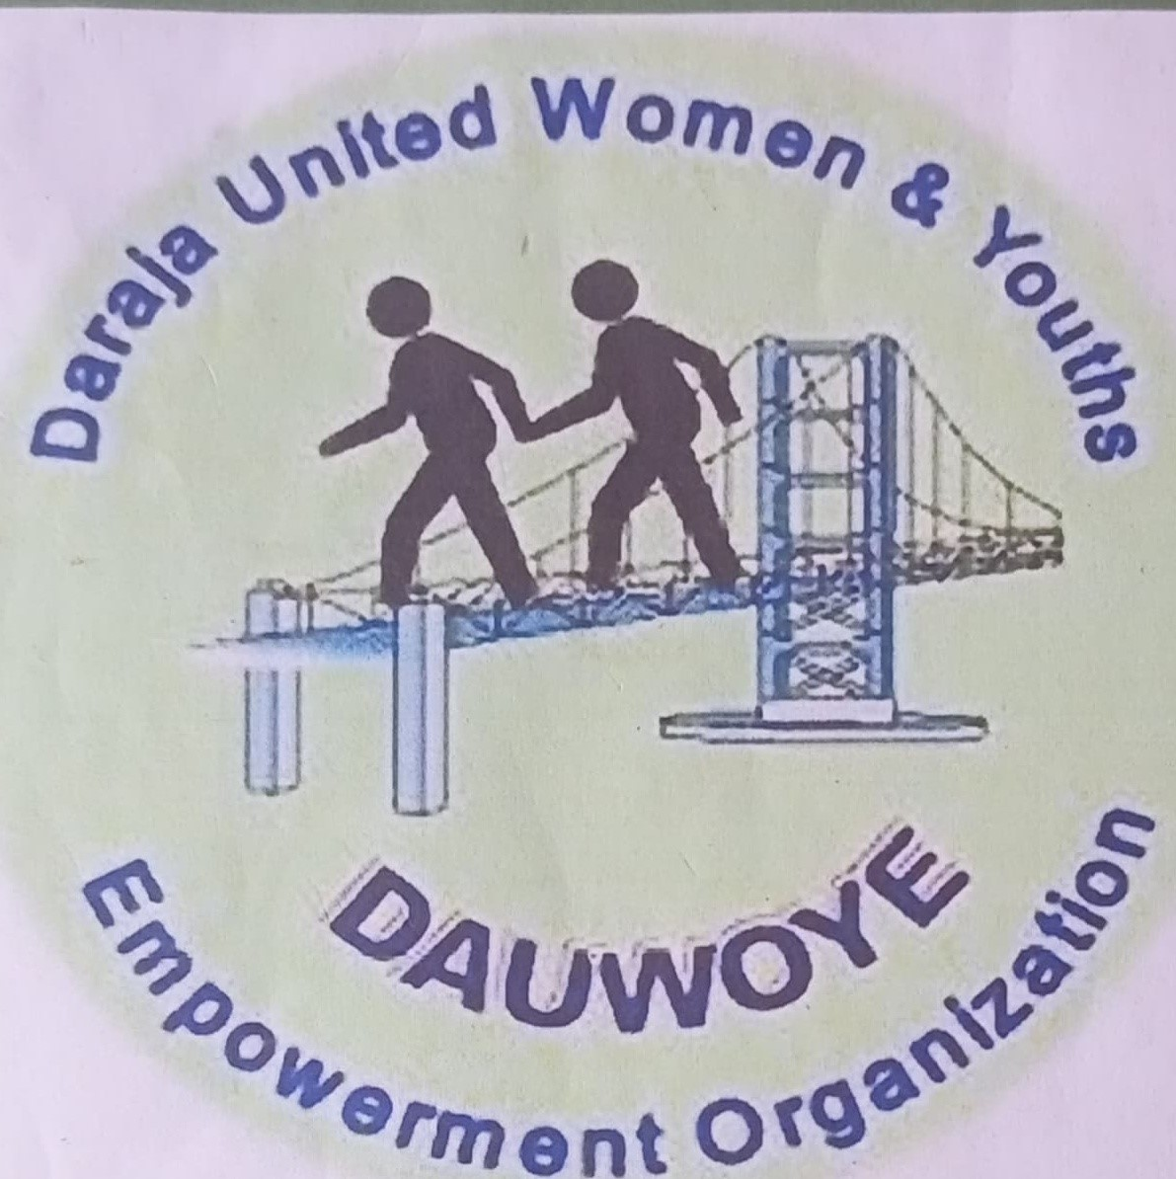

DARAJA-UNITED YOUTH AND WOMEN EMPOWERMENT Empowering Youth and Women

# MASABA BUILDING,KISII.| www.dauwoye.org

BACKGROUND

Daraja United Women and Youth Empowerment (DAUWOYE) was incepted in 1997as a self-help group going by the name of Bidii Women Group. The focus of the organization, back then was to create economic empowerment opportunities for women within Kisii Town. The, then self-help group gave the precedent of how to effectively scan and optimally leverage from existing income generating activities ,and it is through this diligence that DAUWOYE grew to become a CBO known as Daraja United Women Group composed of 10 members in 1999. The main aim of Daraja United Women Group was to proliferate the economic empowerment gains achieved since the organization's inception and participate in HIV prevention activities. It was during this period that the HIV Declaration was made paving the way for the initiation of a variety of HIV Programs. The group's membership was also realigned with the new functions, with only those supporting the rights of HIV patients remaining.

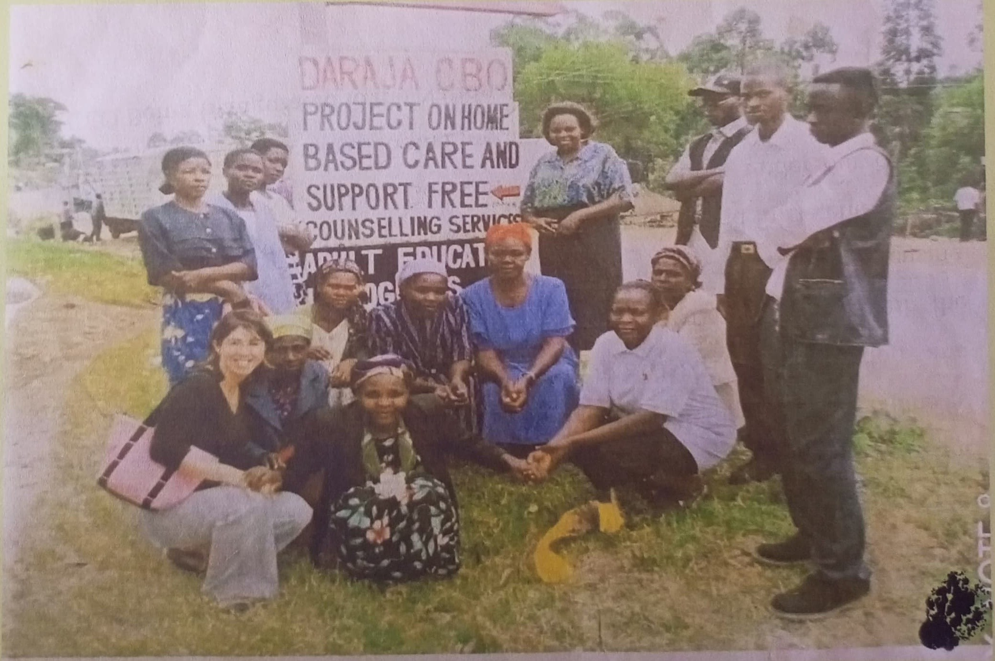



# Photo*: Taking Part in the Home-Based Care Program*

The goal of the organization during this period was to improve the incomes beneficiaries by getting loans from *Care* *Kenya.* In 1999 our vision changed to incorporate health as a social empowerment initiative by accommodating activities geared towards addressing the problem of HIV/AIDS. Most notably, 10% of the profit generated from the women group's activities was channeled towards community capacity building biased to HIV/AIDS prevention and care. DAUWOYE took part in the home-based care program was well with the support of British Interns. The organization took part in several programs focusing on HIIV/AIDs and sexual and reproductive health in general and in December 2007, we registered as an NGO (Non-Governmental Organization) under our current title, Daraja United Women and Youth Empowerment (DAUWOYE).

# The CEO Being Inaugurated to the National NGO Council

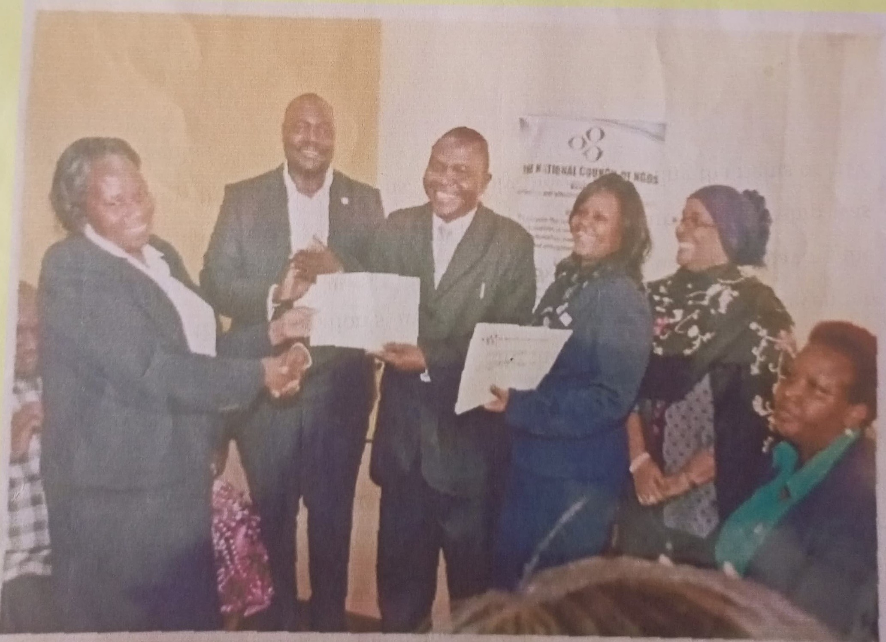



The operations of the organization widened with its new status. In the past decade, DAUWOYE has implemented several projects geared towards benefiting the most vulnerable members of society. From 2015 to 2020, DAUWOYE finished implementing the Closing the Gap (CtG) program funded by Planned Parenthood Global. Currently, we are working with the Kenya Red Cross Society in implementing Global Fund's HIV Prevention Program. Following our commendable performances in project implementation, we had our area of implementation expanded to cover two constituencies, South Mugirango and Bomachoche Borabu in the new phase of Global Fund's HIV Prevention Program (July 2021-June 2024).

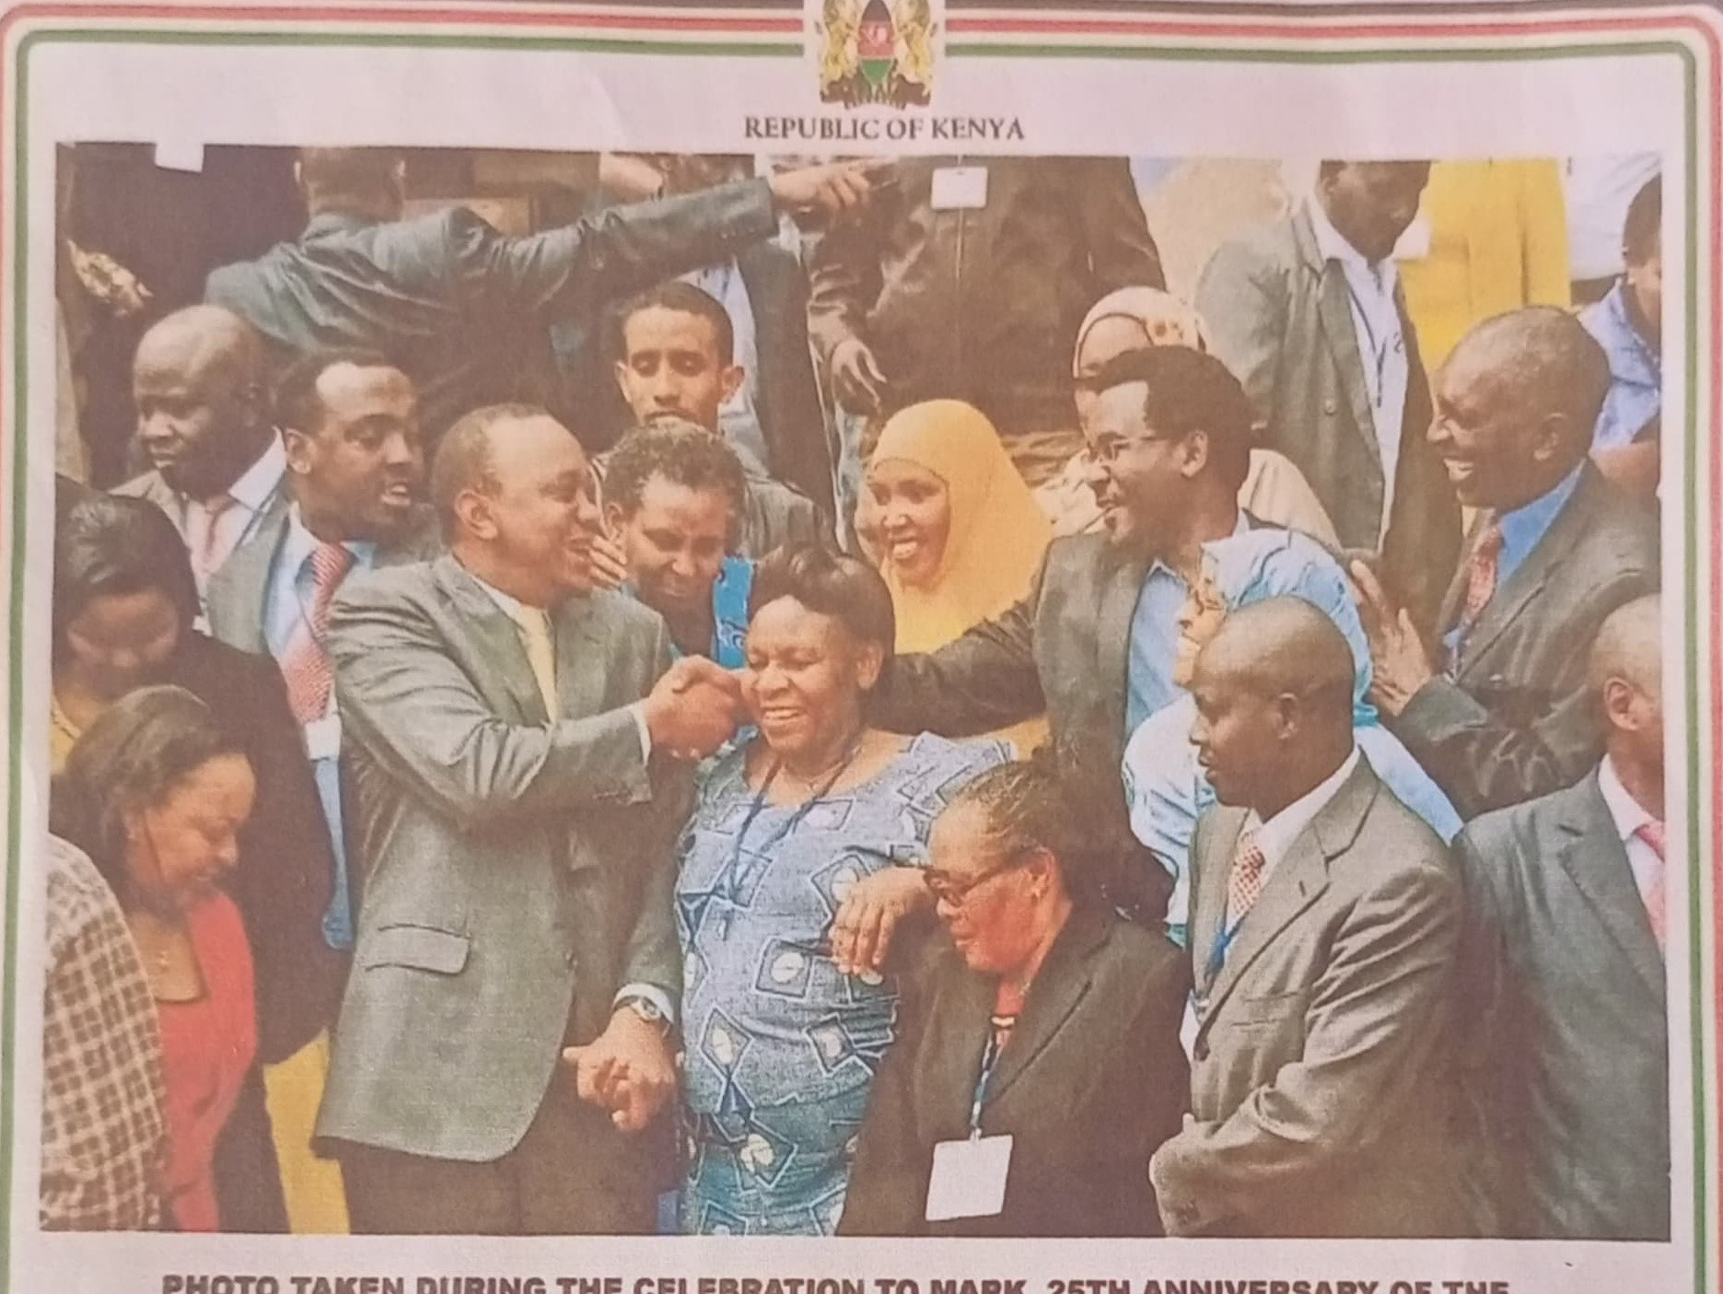

NGO CO-ORDINATION ACT PRESIDED BY H.E. THE **PRESIDENT** **HON.UHURU** KENYATTA AT **KICC NAIROBI ON 1ST AUGUST 2014.**

|  |  |  |
| --- | --- | --- |
| No | Year | Partner |
| 1 | 2001 - 2003 | Futures Group Inter. Through Daraja Medical Centre. |
| 2 | 2004 | M.O.H on HIV/AIDS Prevention and Home/Community Based Care |
| 3 | 2004 - 2012 | Maries stopes on Reproductive Health through Daraja Medical Centre |
| 4 | 2005 | Pact Kenya International. |
| 5 | 2005 to date | PSI on Malaria Prevention and Control |
| 6 | 2005 - 2007 | Umande Trust on Capacity Building for the formed support groups on financial management |
| 7 | 2006 - 2007 | Futures Group through Mild May International |
| 8 | 2011 - 2012 | NACC funding on MARPS (Most at Risk Populations) |
| 9 | 2015 - 2020 | Closing the Gap (CtG) Project |
|  | 2019 to date | Global Fund HIV Prevention Programs |

We aim to galvanize our resources in the pursuit of growth and expand our implementation scope to cover the Western Region by 2025.

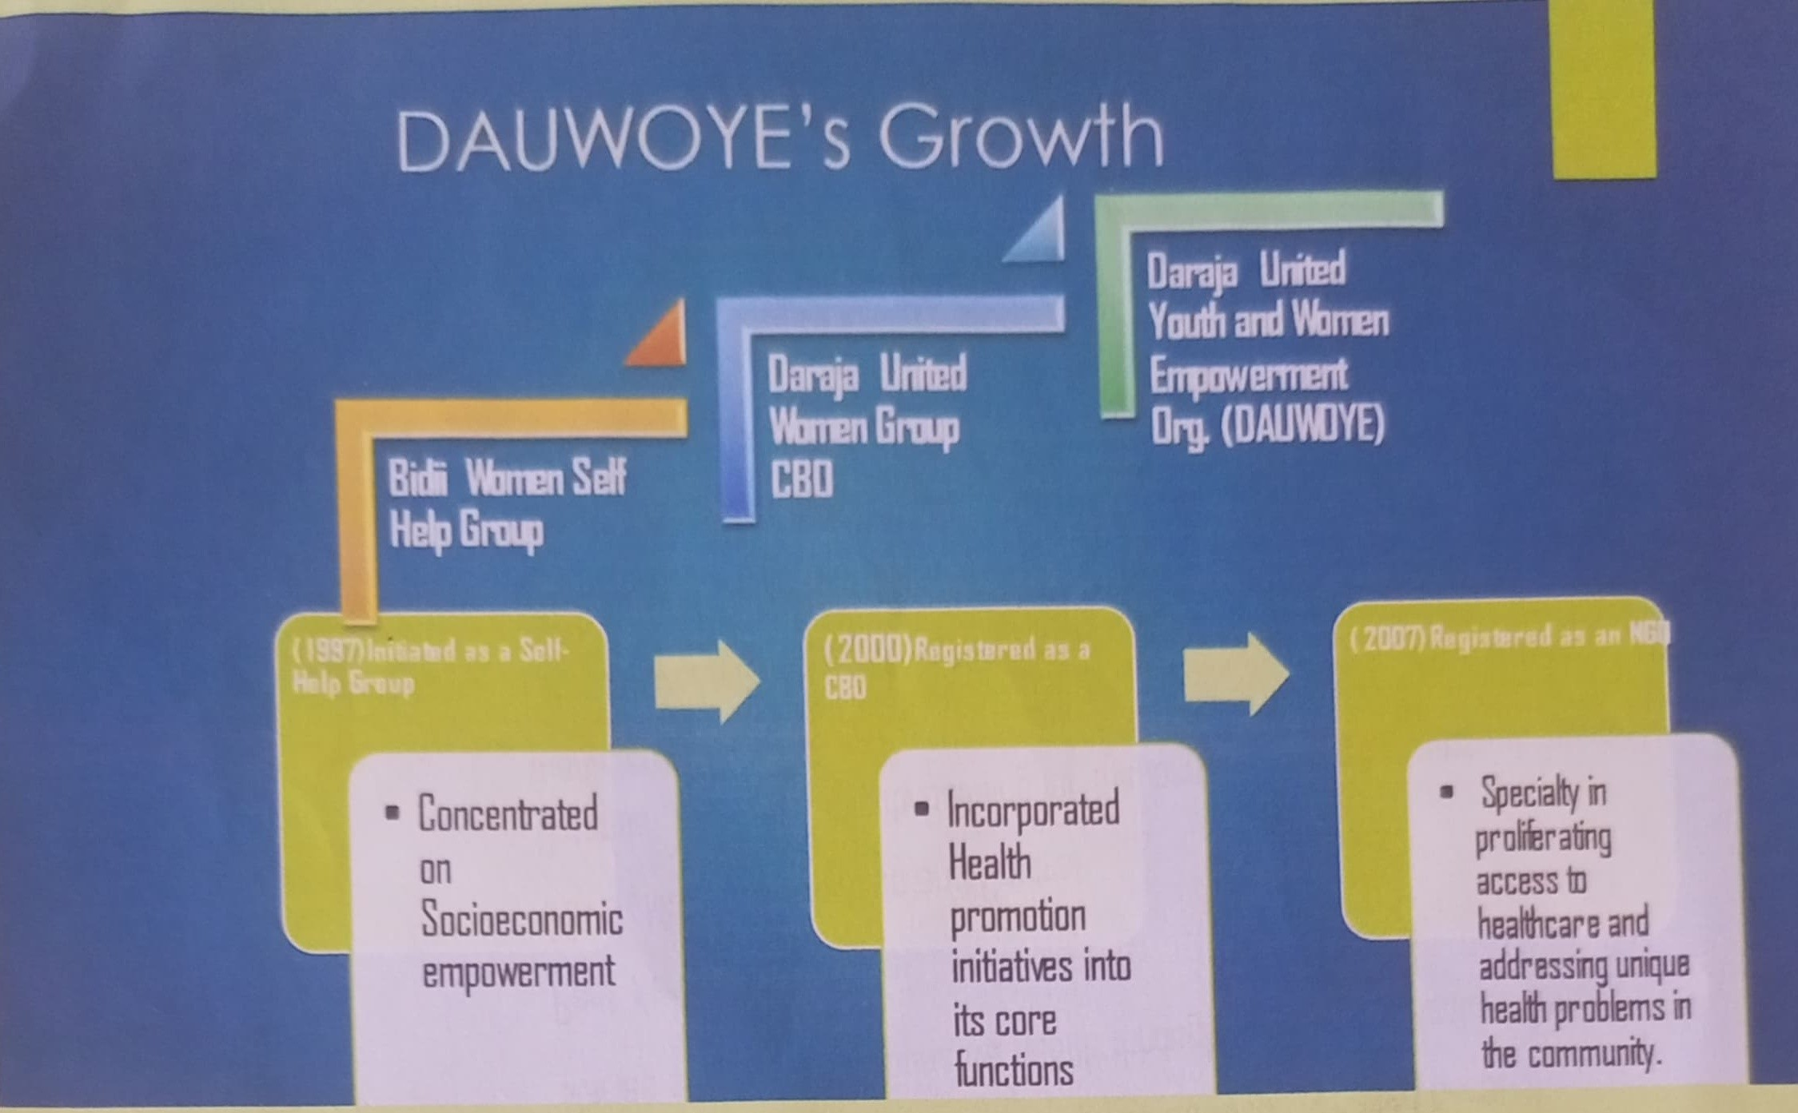

**VISION**

To be a center of reference in quality healthcare delivery and social-economic empowerment through partnership

delivery while creating socio-economic empowerment opportunities for the vulnerable.

**MISSION**

To alleviate barriers in accessing comprehensive health services and promote quality healthcare0

**CORE VALUES**

* Integrity
* Honesty
* Transparency
* Accountability

DAUWOYE

Collaboration and partnership.

DAUWOYE Staff During 2019 Celebrations of World Aids Day

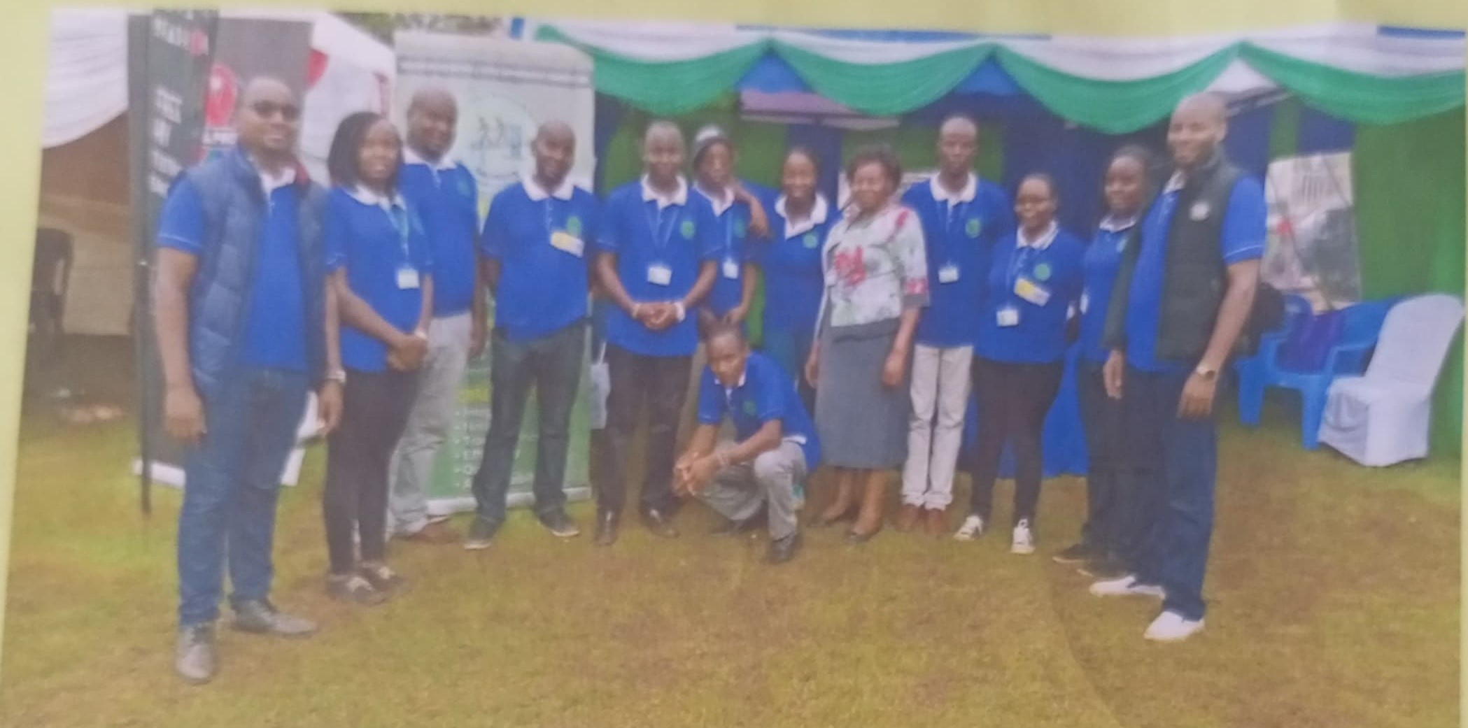

**Our Journey through the Years**

DAUWOYE

To enhance access to socio-economic opportunities in the marginalized communities.

To create an enabling environment for sustainability and success of health and socio-economic program in the communities.

To conduct and document research to help inform in programming and decision-making efforts.

To Realign and improve the institutional development of DAUWOYE Kenya to deliver on its set mandate.

The Organizational Structure

DAUWOYE has a developed and implemented an organizational structure suitable to the sustenance of its operations. At the helm of the organizational structure is a board of directors mandated to supervise the operations of DAUWOYE to ensure the efficient use of resources in the pursuit of the organization's core objectives.

# The Organization's Organogram

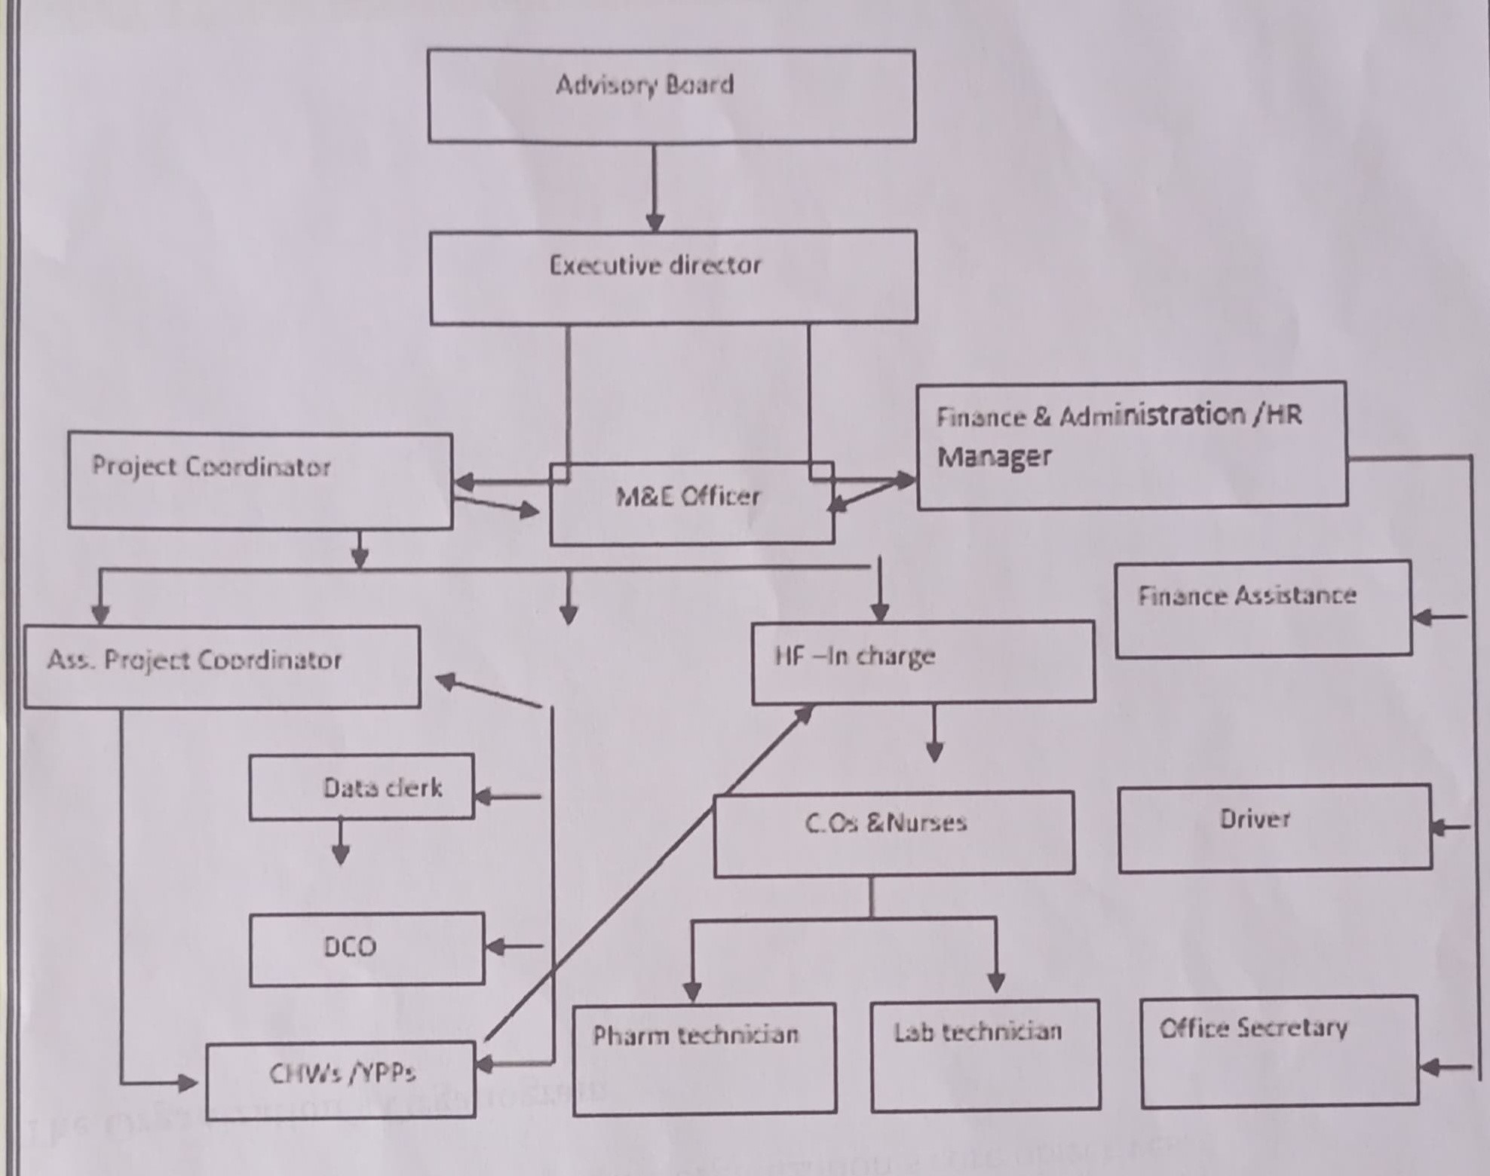

Program Approaches

**Right** **based** **programming-The** organization works towards sensitizing the communities to on their rights by creating awareness on their sexual reproductive health and socio-economic

opportunities/rights.

Participatory development-We engage the beneficiaries in the communities we implement our projects to ensure that the community needs are addressed and to enhance community ownership to enable attain sustainability.

Civil society partnership-We work and network with others to provide quality service delivery and advocacy programs to our clients for comprehensive,

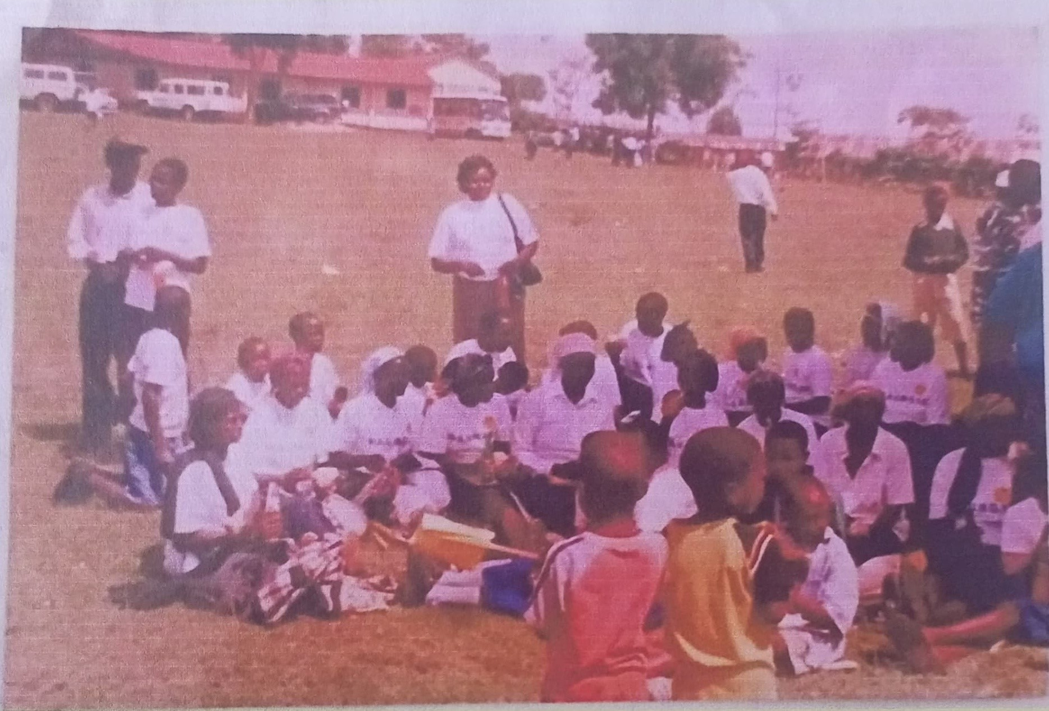Year 2009: Celebrating World AIDS Day at Keumbu,Musa Nyandusi Ground.

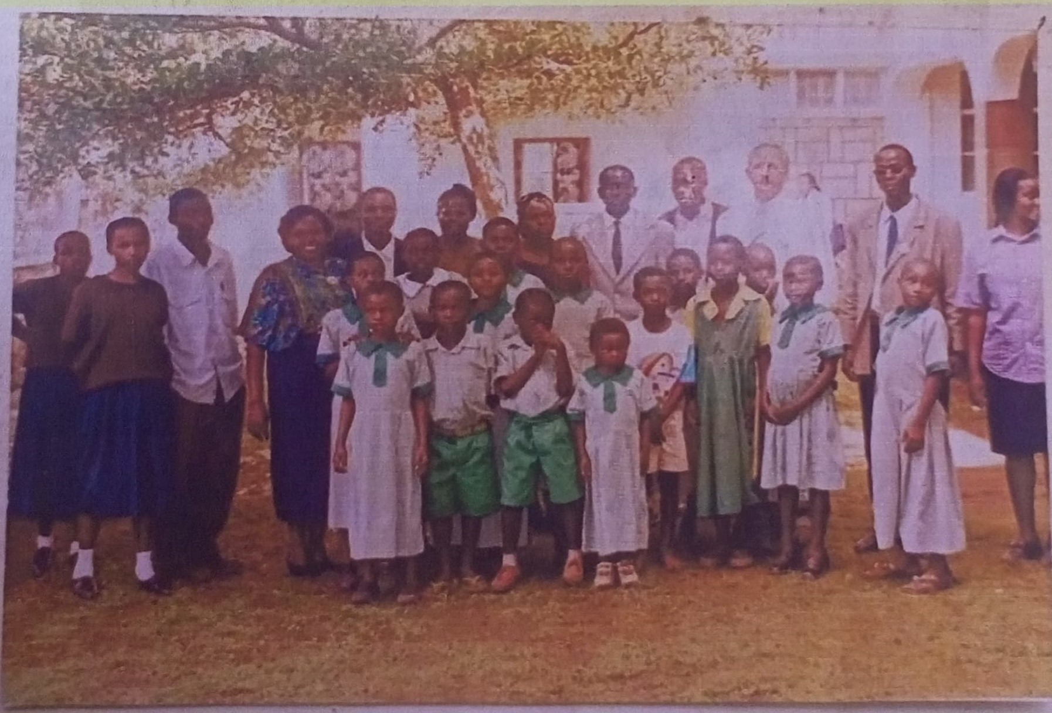

Year 2006: Hosting a Donor Representative at St. Vincent Pastoral Center.

DAUWOYE 

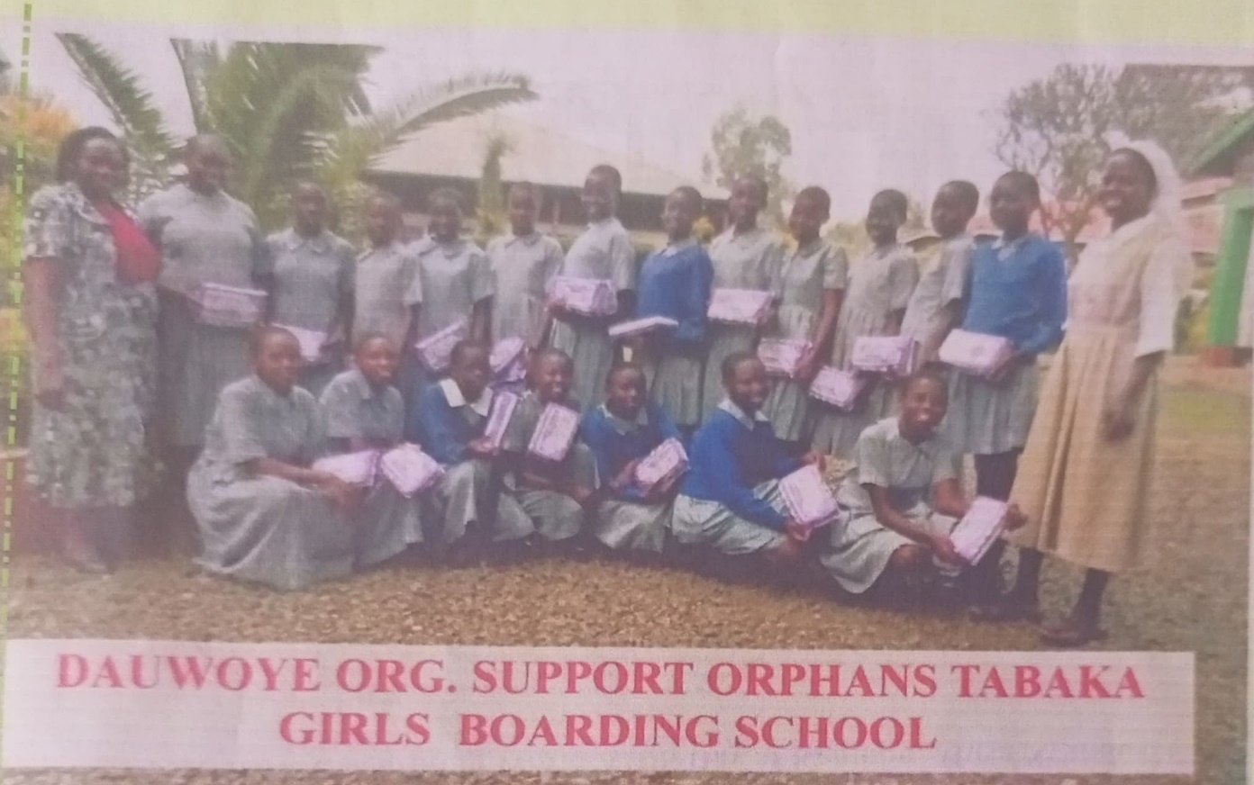 **Year 2016: Sensitization of Girls on Teenage Pregnancies and HIV Prevention**

**ORGANIZATIONAL OBJECTIVES**

To improve access, utilization of quality, affordable and sustainable integrated reproductive health services to all communities. Integrated and sustainable action on holistic health promotion and social economic maintenance.

**Multisectoral Collaborations-We** network and work with stakeholders from various disciplines both governmental and non-governmental to ensure that our program objectives are achieved in the best way possible. We also partner with development partners (donors and sponsors) to galvanize resources for effective program delivery.

**Advocacy-The** organization creates deliberate and concerted efforts on matters to deal with policy and budget frameworks to enhance sustainability of the programs.

Capacity building-we give priority to communities in the rural as this are the most affected due to inadequate accessibility to sexual reproductive health services and socio-economic opportunities.

Responsiveness-As much as possible, our programs will Endeavour to be flexible and responsive to the operating environment, and especially to fluctuations in reproductive health social economic trends and needs.

**Gender, Equity** **and** **diversity-Given** that sexual reproductive health and social economic issues cut across DAUWOYE interventions involves the affected, based on gender at different levels and ensures equitable distribution of resources to our beneficiary to enable us achieve the set objectives.

## FACILITIES

DAUWOYE operates two health facilities through which it delivers its healthcare promotion agenda Daraja Medical Center-Established in 1996.

Daraja Medical Center ANNEX-Established in 2018.

Under the recently concluded CtG program, DAUWOYE built the capacity of facilities within Kisii and Nyamira Counties through, staff training, commodity supply, equipment supplies and upgrades.

Under Kenya Red Cross Society, Global fund HIV Prevention program DAUWOYE is implementing in Kisii County, Gucha South Sub County in South Mugirango constituency. Programmatically the following interventions were carried out during the contracted period;

Behavioral change as part of programs for adolescent and youth i.e. EBIs and mentorship and life skill program.

Community mobilization and norms change i.e. Advocacy forums, community sensitization on human rights violations, CAB meeting.

Comprehensive AYP-friendly outreach services

The HIV Prevention program aims at ensuring Adolescent girls and young women (AGYW) in selected sub counties access to the essential package of biomedical, behavioral and structural interventions above to reduce their vulnerability to HIIV/AIDS infections.

Presence Within the Community

DAUWOYE's project implementation activities are supported by Community Resource Persons (CORPS) as part of its socioeconomic empowerment agenda. Since 2019 we have engaged and empowered over 130 CORPS as illustrated in the table below;

Intervention Number of People Trained

|  |  |
| --- | --- |
| SHUGA | 20 |
| My Health My Choice | 16 |
| Healthy Choices for a Better Future | 16 |



|  |  |
| --- | --- |
| Sister to Sister | 20 |
| Mentorship | 20 |
| GBV Community Champions | 20 |
| Peer Educators | 18 |
| Total | 130 |

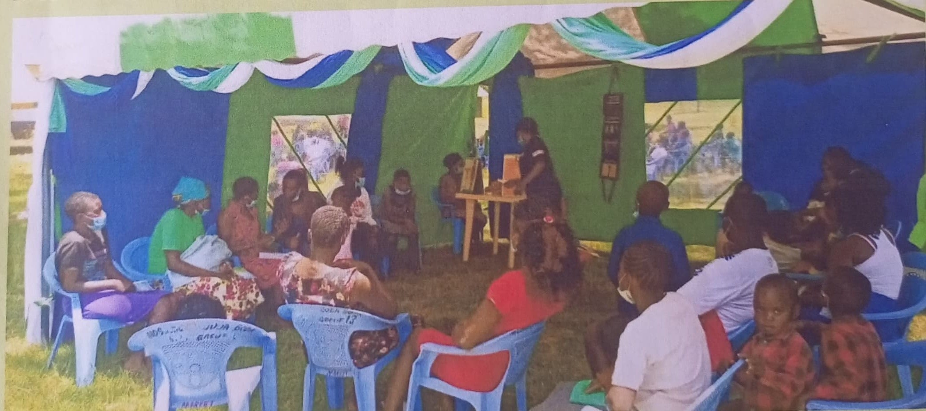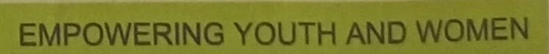DAUWOYE CHVs Participating in World Contraceptives Day

|  |  |  |  |  |  |
| --- | --- | --- | --- | --- | --- |
|  |  |  | Contract Targets | | |
| Module | GF PF Indicator |  |  | | |
| 2019 | 2020 | 2021 |  |
| HTS | # of people reached with HTS | 1,792 | 10,700 | 3,900 |  |
| # of people who turned HIV positive | 0 | 0 | 0 |  |
| # of people who turned HIV positive and linked to treatment, care and support. | 0 | 0 | 0 |  |
| AGYW | # of adolescent girls and young women (AGYW) reached with HIV prevention programs-defined package of services | 3,112 | 10,700 | 3,900 |  |
| # of adolescent girls and young women(AGYW) reached with Cash Transfer and  Dignity Kits | 0 | 0 | 0 |  |
| HRG | # of people reached Know Your Rights Campaign | 225 | 300 | 0 |  |
| # of human rights violation cases reported | 0 | 0 | 0 |  |
| # of human rights violation cases addressed | 360 | 0 | 0 |  |

### PROGRAM PERFORMANCE MATRIX

|  |  |  |  |  |  |  |  |  |
| --- | --- | --- | --- | --- | --- | --- | --- | --- |
|  |  |  | Contract Targets | |  | Percentage perform | | |
| Module | GF PF Indicator |  |  | |  |  | | |
| 2019 | 2020 | 2021 | 2018 | 2019 | 2020 | 2021 |
| HTS | # of people reached with HTS | 1,792 | 10,700 | 3,900 | N/A | 1,015 | 2,232 | 1,930 |
| #of people who turned HIV positive | 0 | 0 | 0 | N/A | 01 | 01 | 0 |
| # of people who turned HIV positive and linked to treatment,care and support. | 0 | 0 | 0 |  | 01 | 01 | 0 |
| AGYW | # of adolescent girls and young women (AGYW) reached with HIV prevention programs-defined package of services | 3,112 | 10,700 | 3,900 |  | 4,477 | 5,179 | 4,129 |

|  |  |  |  |  |  |  |  |  |
| --- | --- | --- | --- | --- | --- | --- | --- | --- |
|  | # of adolescent girls and young women (AGYW) reached with Cash Transfer and  Dignity Kits | 0 | 0 | 0 | N/A | 0 | 0 | 0 |
| HRG | # of people reached Know Your Rights Campaign | 225 | 300 | 0 | N/A | 150 | 405 | 0 |
| # of human rights violation cases reported | 0 | 0 | 0 |  | 0 | 0 | 04 |
| # of human rights violation cases addressed | 360 | 0 | 0 | N/A | 0 | 0 | 04 |

the target was also 3900 however due to stigma and discrimination associated with HIV in the community managed to screen and tested few who were legible for testing.

The numbers of beneficiaries reached 2018-2019

|  |  |  |  |  |
| --- | --- | --- | --- | --- |
| INTERVENTION |  | MALE | FEMALE | TOTAL |
| SHUGA |  | 87 | 307 | 394 |
| MHMC |  | 130 | 361 | 491 |
| HCBF |  | 81 | 397 | 478 |
| FMPII | DAUW | OYE68 | 210 | 278 |
| Outreach |  |  |  | 4,385 |
| S2S |  |  | 82 | 82 |

The numbers of beneficiaries reached 2020-2021

|  |  |  |  |
| --- | --- | --- | --- |
| INTERVENTION | MALE | FEMALE | TOTAL |
| SHUGA | 24 | 96 | 120 |
| MHMC | 211 | 621 | 832 |
| HCBF | 442 | 1,670 | 2112 |
| FMPII | 50 | 194 | 244 |
| Mentorship | 1173 | 2827 | 4000 |
| Outreach | 4,388 | 6,768 | 11,156 |
| S2S | 0 | 263 | 263 |

2.1 Programs to reduce human rights-related barriers to HIV services

Human rights Sensitization campaign meetings were conducted in all the three working wards sensitizing the local, religious, and opinion leaders on Human Rights related Barriers to HIV services. The total numbers of AGYW reached with the information were as follows;

1. Know your rights campaigns were carried out in the three operating wards targeting AGYW with the information of reducing Barriers related to HIV/AIDS. In 2019 six campaigns were conducted in quarter 8, target of 240 adolescents however managed to achieve a total number of 374 Adolescents Girls and Young Women.
2. In 2020,8 Know your right campaigns were carried out targeting 300 AGYW with the information of reducing barriers related to HIV/AIDS however because of overriding on outreaches managed to sensitize 405 adolescents.

17|Page

1. In 2021 there wasn't allocation on know your rights campaign as much of the targets were achieved in 2020.

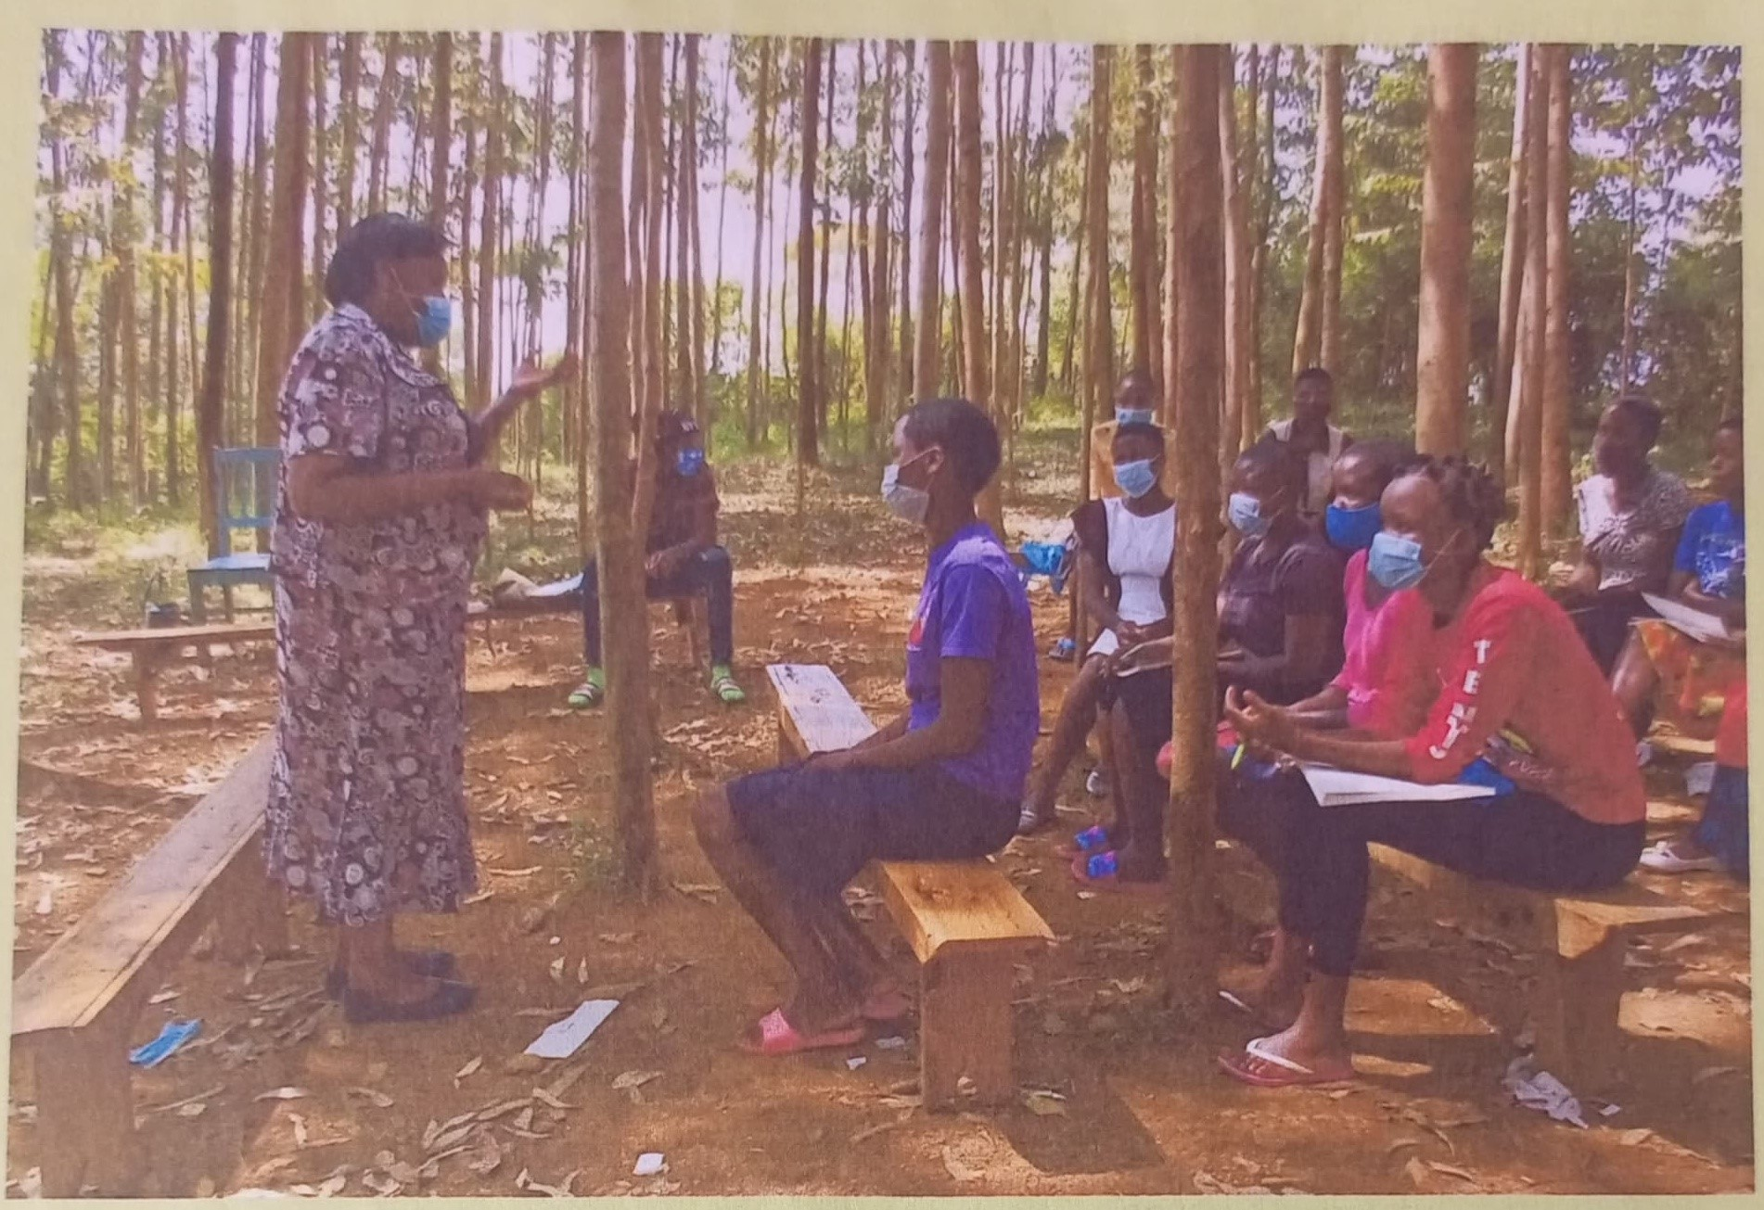

The following information was shared during know your rights campaign;

Introduction to Human Rights and discussion of human rights principles relevant to HIV/AIDS, and the ways a person can protect someone's fundamental human rights. The following fundamental

human rights principles were discussed in detail;

Patient rights in a healthcare facility.

A client has a right to receive health services that are accessible, acceptable and of quality.

Patient has a right to reproductive health, to access treatment obtained by a trained professional for condition scoring during pregnancy The right to emergency medical treatment.

Right to confidentiality.

Children under 5yrs have a right to free and compulsory vaccination.

Discussed sexual violence and the law, narrated different definitions and the background to sexual offences Act. The sexual offences and punishment Act like rapes were discussed and the penalties for violation.

The Redress mechanism, violation rights means when a government or any other duty bearer fails to respect, observe, protect, promote and fulfil human rights. Examples of human rights that are violated include; Breach of rights to privacy, breach of right to Work etc.

In case human rights violation one can visit the judiciary, HIV/AIDS tribunal and the Kenya national commission on human rights to seek justice, discussed different ways a person can get assistance for Rights violations of adolescents living with HIV/AIDS with the assistance from the pro bono lawyers.

MONITORING AND EVALUATION

Keeping records and monitoring activities, this helps to see progress and builds a sense of achievement whether the project is on the right track targeting the right indicator. The records are useful in the M&E system as they are essential when applying for funding.

Support project/program implementation with accurate, evidence-based reporting that informs management and decision-making to guide and improve project/program performance.

Contribute to organizational learning and knowledge sharing by reflecting upon and sharing experiences and lesions so that we can gain the full benefit from what we do and how we do it.

Upholding accountability and compliance by demonstrating whether or not the work has been carried out as agreed and in compliance with established standards and wit donors' requirements

Provide opportunities for stakeholders' feedback, especially beneficiaries, to provide input into and perceptions of our work, modelling openness to criticism and willingness to learn from experiences and to adapt to changing needs.

Promote and celebrate the work by highlighting accomplishments and achievements, building morale and contributing to resource mobilization.

Communicating the data, it's important to communicate the data to the relevant stakeholders e.g. community groups, community, donors, and the policy makers. This involves tailoring and packaging the data to key stakeholders and drawing out the lessons for key stakeholders.

Process monitoring, routine data collected and analyzed in order to establish whether the project tasks and activities are leading towards the intended project results. This kind of monitoring measures the inputs, activities and outputs. In other words, process monitoring answers the questions what has been done so far, where, when and how has it been done.

Technical monitoring, assessing the strategy that is being used in project implementation to establish whether it is achieving the required results. The technical aspect of the project involves the activities to be conducted.

**CAPACITY BUILDING**

|  |  |  |
| --- | --- | --- |
| S/No: | Group | Capacity Building Activities. |
| 1. | Community Actors | Attended a Psychosocial First Aid Training.  Attended a paralegals training.  Attended a GBV champion training.  Attended a 3 day sensitization on PrEP. |
| 2. | Staff | The P.O, MEO and Field Officer attended a Result Based Monitoring  and Evaluation Training. |

|  |  |  |
| --- | --- | --- |
|  |  | The P.O attended a SASA Together! TOTs training.  The Field Officer attended a paralegals' training.  The P.O attended a GBV TOT training.  All Staffs attended a Psychosocial First Aid Training. |
| 3. | Board Members | The Board Members attended a system strengthening session that  was facilitated by The KRCS Regional Advisory  Board Member and the RPC. |

**PROGRAMME DOCUMENTATION**

**Program successes.**

The Community Adolescents Treatment Supporters (CATS) and the youth group aimed at

supporting their peers to live positively without stigma and discrimination and to promote adherence to ART treatment. The program has ably created a safe space for the youths enabling them to access health services such as sexual and reproductive health services and ART treatment at the facility without reservations. During the implementation of the program, the number of youths accessing services at the facility doubled. The facility empowered community treatment supporters greatly to act independently by training them to provide HIV counseling to clients, dispensing ART drugs and other services at the facility. This has assisted greatly in adherence hence one of the beneficial under the care of the community treatment supporters delivered HIV negative baby in the facility recording a success story among AYPLHIV.

Investing in communities. This involves building up the capacity of community leaders to deliver human rights services, advocate against human rights violation and monitor their quality. It also involves scaling up peer-based support which has proved effective in improving adolescents' adherence to treatment and retention in care.

Scaling up successful interventions; such as peer support groups and mobile communication platforms i.e. use of whatsApp and messages - to keep adolescents in care and adherence to drugs.

Community mobilization and participation has made substantial contributions to HIV prevention, including among AGYW. Large-scale community outreach was a key success in expanding community-based HIV testing through community outreaches, which also contributed towards empowering adolescents and youth towards changing norms and generating service demand.

Through facilitation stipend paid to our Volunteers during implementing of different interventions has empowered them economically i.e coming up with income generating actives such as rearing of small poultry, taking up the burden of school fees, building shelters.

The program has improved linkage between local community, local administration and MOH facilities.

Challenges

We still operate on a rented premises and this predisposes us to financial difficulties, hence the need for resources to establish an owned office premises.

The lack of an ambulance in our health facilities limits our reach into the communities we serve and prevents us from advancing accessibility to care services.

The Covid-19 pandemic affected our service delivery mechanisms and it continues to impose unique challenges to the organization.

**2.2 Lessons learnt/Best Practices.**

The program used the trainings conducted to identify AGYW champions. These champions were further trained to act as referral network for the girls. AGYW champions who are from all the sub-counties are trained on the appropriate channels of communication to report sexual violations and violations of land and property rights

It is a good practice to ensure rigorous selection of trainees in every activity so that, confident, self-disciplined, hardworking and persistent trainees are found by screening them using a participatory process involving village elders, chiefs, parents and friends of the AGYW. This process, when conducted well, yields good trainees with a high completion rate who will in turn be able to train other AGYWs within the communities. It is good practice to work and build on existing structures and align the Program activities to those of a government and community. Using these institutions and structures leave them stronger and sustainable.

Community mobilization and awareness is important in addressing community issues. Communities knowing their rights is important in community action. This action is precipitated by community mobilization and awareness.

Involvement of young people are being appreciated as a resource for changing the course of the epidemic. They are responsive to HIV prevention programs and are effective promoters of HIV prevention action. Investing in HIV prevention among young people is likely to contribute significantly to a more sustainable response to HIV/AIDS. Some of the agenda included introduction of the stakeholders and duty-bearers, AGYW invited reported some cases they have been dealing with or experiencing, pro-bono lawyers would then take up the cases and in these forums, some of the cases were documented by the pro-bono lawyers and the duty bearers

One significant outcome of this practice is the healthcare workers (nurses and clinical officers) laid out challenges in offering services to AGYW during community outreaches, dispelled myths and misconceptions concerning HIV/AIDS issues. This enabled the AGYW to better understand the perspectives of the health workers as well as appreciate their work.

This practice also offered a good opportunity for the project and other community members to identify new stakeholders within the sub-county and build a strong network within the sub-county to give the AGYWs a safe space.

Community mobilization and awareness is important in addressing community issues. Communities knowing their rights is important in community action. This action is precipitated by community mobilization and awareness. There exists knowledge and expertise from the people we serve irrespective of their status in life. Their participation in Program planning as well as consulting them enriches the quality of Program implementation. For example, working with adolescent girls made the project aware of the special needs of the adolescent girls and young women.

Engaging the community through existing organizations, groups, and structures for education and support.

# Challenges Faced

We operate on rented premises, which predisposes us to financial constraints. This also limits the sustainability of our organization because our model relies on donor funding to a significant extent.

We are at times, unable to reach members of the communities we serve because of the lack of an ambulance to serve our facilities. This resource can help increase access to care among patients within the community.

**Recommendations for future programming.**

Expand and strengthen our engagement with the learning institutions on partnership to for better dissemination of information to the target groups.

There is need to strengthen SMS platforms and reporting systems for GBV cases to accelerate access to justice.

Adolescents Girls and Young Women have a role to play in ensuring sexual reproductive health protection in their communities. It is important to scale up the engagement and capacity building of AGYW.

Future programming should focus on interventions targeting the weakest links in the referral system. There is need to rejuvenate law enforcement partners to improve responses to SRHR violations. There is need to incorporate mental health services into future programs due to recent rise in suicidal rates.